

Lab Report
Only for course Teacher
 |  | Needs Improvement | Developing | Sufficient | Above Average | Total Mark
Allocate mark & Percentage |  | 25% | 50% | 75% | 100% | 40
Understanding/Analysis | 10
Implementation | 15
Accuracy | 10
Task Efficiency | 5
Total obtained mark
Comments

Semester: Summer 2026
Student Name: AKM Murtoza Basir Sojeeb
Student ID: 242-35-846
Batch: 43 Section: B2
Course Code: SE231
Course Name: System Analysis & Design Capstone Project
Course Teacher Name: Dr. Kamrul Islam Shahin
Designation: Associate Professor
Submission Date: 12th August 2026

FARMFUSION; SMART AGRO DIARY
ECOSYSTEM
Project Report
SE231 – System Analysis & Design Capstone Project

Presented to
Dr. Kamrul Islam Shahin
Associate Professor

Section: B2
Group: 08
Foysal Ahmed (242-35-530)
AKM Murtoza Basir Sojeeb (242-35-846)
Tasfiq Ahammed Ratul (242-35-659)
Omar Faruk Khan (242-35-338)
Based on the submitted project presentation
Table of Contents
- Project Objective……...............................................................................4
- ER Diagram…...........................................................................................4
- Description of the ER Diagram.................................................................5
- Class Diagram………...............................................................................6
- Description of the Class Diagram.............................................................6
- Sequence Diagram……............................................................................8
- Description of the Sequence Diagram......................................................8
- Conclusion…………................................................................................9

Project Objective

Many farms still rely on manual or disconnected systems, making farm management inefficient. FarmFusion is a smart online agro-diary that simplifies daily farming tasks through one centralized platform. It helps farmers manage their activities while enabling experts and administrators to provide better support.
The project is designed around a centralized platform for managing farming activities and the supporting information required by farmers, experts and administrators.
Reference: Project presentation, Slide 2.

ER Diagram
The Entity–Relationship (ER) diagram represents the data structure of the FarmFusion Smart Agro System. It identifies the major entities, their attributes, primary keys, foreign keys and the relationships among them. The diagram also shows relationship cardinalities and groups entities according to their functional modules.
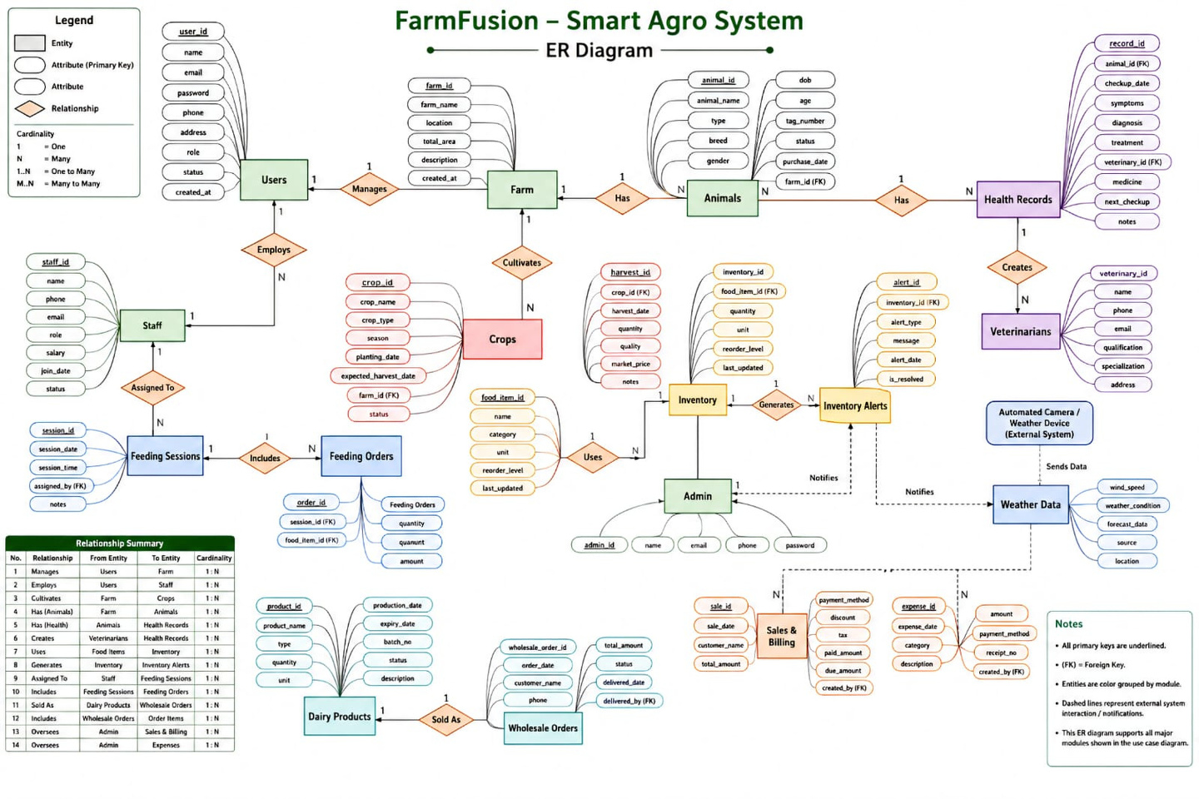
Figure 1: ER Diagram of the FarmFusion – Smart Agro System
Reference: Project presentation, Slide 3; diagram reproduced from the submitted PPTX.

Description of the ER Diagram
Users and Farm: Users manage farms. Users stores user_id, name, email, password, phone, address, role, status and created_at. Farm stores farm_id, farm_name, location, total_area, description and created_at.
Farm and Animals: A farm has animals. Animals stores animal_id, animal_name, type, breed, gender, date of birth, age, tag number, status, purchase date and farm_id.
Animal Health Management: Animals are connected with Health Records. Health Records stores record_id, animal_id, checkup date, symptoms, diagnosis, treatment, veterinary_id, medicine, next checkup and notes. Veterinarians are connected with health-record creation.
Farm and Crops: A farm cultivates crops. Crops stores crop_id, crop_name, crop_type, season, planting_date, expected_harvest_date, farm_id and status.
Staff and Feeding: Users employ Staff, and staff members are assigned to Feeding Sessions. Feeding Sessions include Feeding Orders, connecting feeding activities with food items.
Inventory: Food Items are used in Inventory. Inventory records inventory_id, food_item_id, quantity, unit, reorder_level and last_updated. Inventory can generate Inventory Alerts.
Weather and Alerts: Weather Data receives information from the Automated Camera / Weather Device (External System). Weather Data includes wind_speed, weather_condition, forecast_date, source and location, and it can notify the system through alerts.
Dairy Products and Wholesale Orders: Dairy Products are connected with Wholesale Orders through the Sold As relationship. The model stores product, production and wholesale-order information.
Sales, Billing and Expenses: Sales & Billing records sales information, while Expenses records expense_date, category, description and payment-related information. Admin oversees these activities.
The diagram notes that primary keys are underlined, foreign keys are marked as FK, entities are grouped by module, and dashed lines represent the external system. Its relationship summary presents the major relationships with 1:N cardinality.

Class Diagram
The class diagram describes the object-oriented structure of FarmFusion. It shows the principal classes, their attributes, operations and relationships, providing a structural view of how the system's major functions are represented.
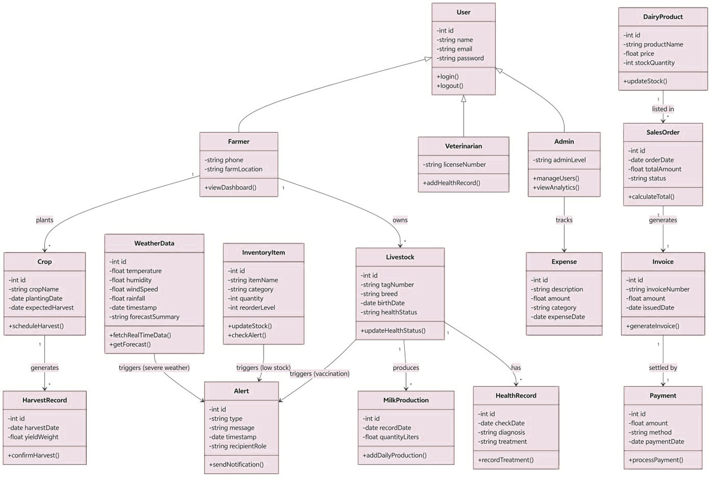
Figure 2: Class Diagram of the FarmFusion system
Reference: Project presentation, Slide 4; diagram reproduced from the submitted PPTX.

Description of the Class Diagram
User: The User class contains id, name, email and password, with login() and logout() operations. Farmer, Veterinarian and Admin are connected to the User class.
Farmer: Farmer contains phone and farmLocation and provides viewDashboard(). Farmer plants Crop and owns Livestock.
Crop and HarvestRecord: Crop stores crop information and provides scheduleHarvest(). Crop generates HarvestRecord, which stores harvestDate and yieldWeight and provides confirmHarvest().
Livestock and MilkProduction: Livestock stores tag number, breed, birth date and health status and provides updateHealthStatus(). It produces MilkProduction, which stores recordDate and quantityLiters and provides addDailyProduction().
HealthRecord and Veterinarian: HealthRecord stores checkDate, diagnosis and treatment and provides recordTreatment(). Veterinarian contains licenseNumber and provides addHealthRecord().
WeatherData and Alert: WeatherData stores temperature, humidity, windSpeed, rainfall, timestamp and forecastSummary and provides fetchRealTimeData() and getForecast(). Severe weather can trigger an Alert.
InventoryItem and Alert: InventoryItem stores itemName, category, quantity and reorderLevel and provides updateStock() and checkAlert(). Low stock can trigger an Alert.
Admin, Expense and Invoice: Admin contains adminLevel and provides manageUsers() and viewAnalytics(). Admin tracks Expense. SalesOrder generates Invoice, and Invoice is settled by Payment.
DairyProduct and SalesOrder: DairyProduct stores productName, price and stockQuantity and provides updateStock(). DairyProduct is listed in SalesOrder, which provides calculateTotal().
Payment: Payment stores amount, payment method and payment date and provides processPayment().

Sequence Diagram
The sequence diagram represents the registration and OTP verification process. It shows the order of interaction among the User, System, Database (DB) and Verification System.

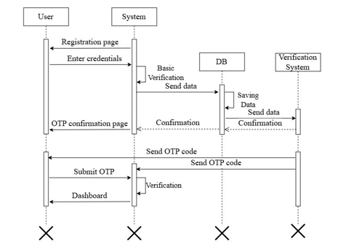
Figure 3: Registration and OTP verification sequence
Reference: Project presentation, Slide 5; diagram reproduced from the submitted PPTX.

Description of the Sequence
- The User starts from the Registration Page.
- The User enters credentials and sends them to the System.
- The System performs basic verification and sends the data to the Database.
- The Database saves the data and sends data to the Verification System.
- The Verification System returns confirmation, and the System shows the OTP confirmation page.
- The Verification System sends the OTP code to the User.
- The User submits the OTP to the System.
- The System verifies the OTP.
- After successful verification, the User reaches the Dashboard.

Conclusion
The ER diagram, Class Diagram and Sequence Diagram provide a clear representation of the FarmFusion Smart Agro Diary Eco System. They support the planning of the system structure, object relationships and interaction flow.

Advantages of ERD, Class & Sequence Diagram
- Clear planning removes risks.
- Enables reliable implementation and future enhancements.
- Ensures a scalable, efficient, and well-structured design.
- Supports the design of large projects.
Reference: Project presentation, Slide 6.

……………………….…………..………..…………….……..

